**Home work**

**Task 1.**

Condition: Write a program that outputs each number of the sequence 1 2 18 90 3 on a separate line

**Sample Output:**

1

2

18

90

3

Paste your code here:

…

**Task 2.**

Condition: Write a program that outputs such a drawing

**Sample Output:**

1

2 2

3 3 3

4 4 4 4

5 5 5 5 5

Paste your code here:

**Task 3**

Write a program that would output such text:

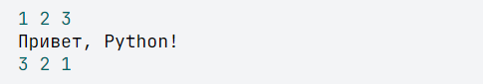

**Sample Output:**

1 2 3

Привет, Python!

3 2 1

Paste your code here:

**Task 4**

Condition: Write a program that reads four lines, and then outputs them in the same sequence. Each of them should be displayed on a separate line

**Sample Input:**

Hi

How are you?

I am fine

Ok

**Sample Output:**

Hi

How are you?

I am fine

Ok

Paste your code here:

**Task 5**

Condition: Write a program that receives a person's name as input, displaying the word "Hello" (without quotes), followed by a comma, a space, then his name and an exclamation mark

**Sample Input:**

Robert

**Sample Output:**

Hello, Robert !

Paste your code here: